Create And Configure IBM Cloud Services-

**Create Node-RED Services**

|  |  |
| --- | --- |
| Date | 3 September 2022 |
| Team ID | PNT2022TMID41338 |
| Project Name | Project – Smart Farmer-IoT Enabled smart Farming Application |

Download node.js

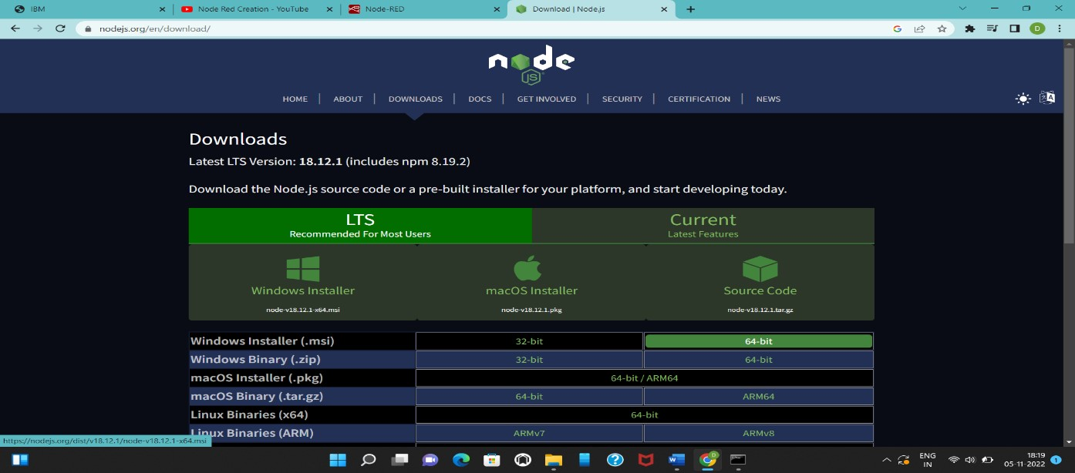

Getting Node-RED link by using command prompt

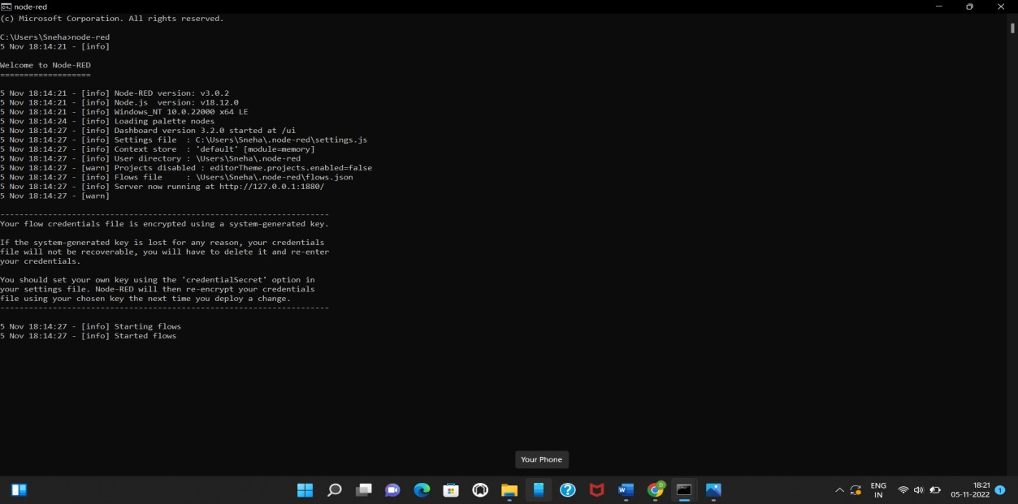

Node-RED

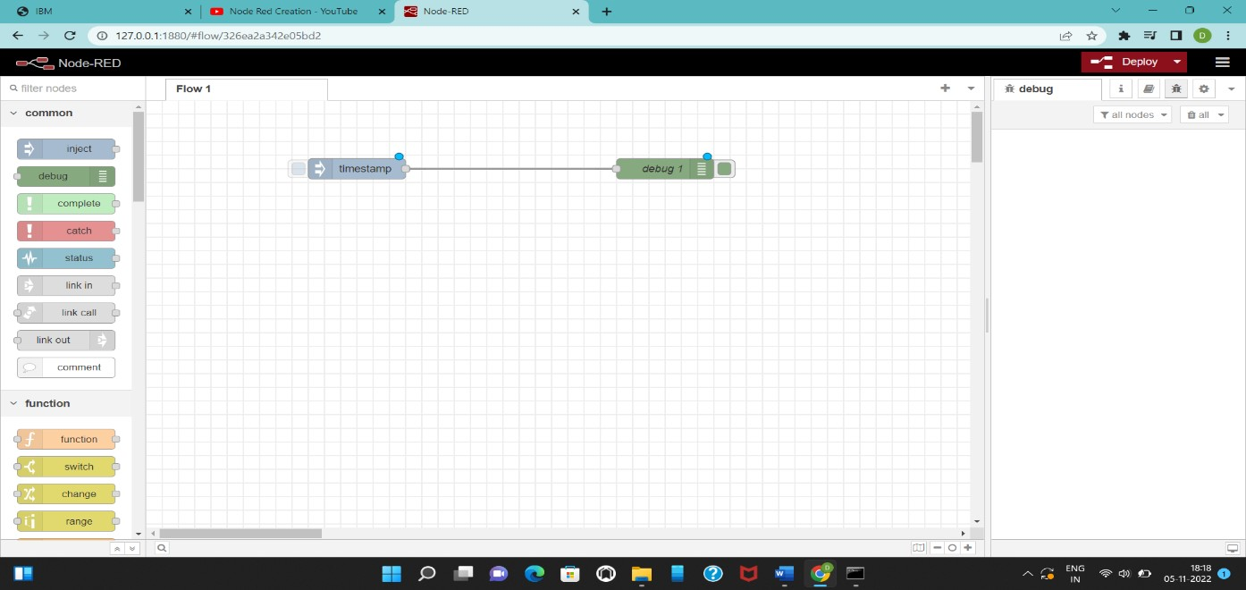

ibmiot to nodered connection

